Baked Halibut with White Wine, Olives, Capers and Tomatoes
This recipe and photos were provided by Sally Roeckell and were originally published at Table and Dish.

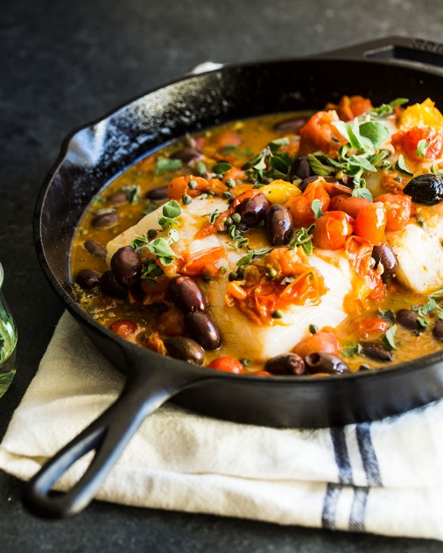
Ingredients
- Extra virgin olive oil for drizzling
- 3 shallots, thinly sliced
- 3 garlic cloves, thinly sliced
- 10 ounces grape tomatoes
- Salt and pepper to taste
- 3/4 cup dry white wine, divided
- 3 tablespoons capers
- 1/2 cup Kalamata olives, pitted and halved
- 1 1/2 pounds thick-cut halibut fillet, de-boned
- 3 sprigs oregano, leaves only

Method
- Preheat oven to 350°F.
- In a cast-iron pan on medium heat, drizzle a little EVOO. Add the shallots and sauté for 2-3 minutes.
- Next, add the garlic and cook until fragrant, 1-2 minutes. Add the tomatoes and cook for 5 minutes.
Once tomatoes start to soften, very carefully smash them using a potato masher. Don’t smash them too much, just enough to release their juices. Stir and season with pepper.
- Deglaze the pan with 1/2 cup of the white wine, scrapping up any brown bits. Cook for 2-3 minutes to thicken slightly. Add in the capers and olives.
- Make a little space in the middle of the pan for the fish to sit. Place the fish in the pan and sprinkle with salt and pepper. Add oregano leaves. Scoop some of the tomato mixture over fish and top with 1 sprig of oregano. Add in the remaining 1/4 cup of white wine around the fish.
- Place in the oven, uncovered, to bake for 20 minutes or until cooked to your preferred doneness. Serve hot.

